17 November 2023
Target achieved | Progress | Regress
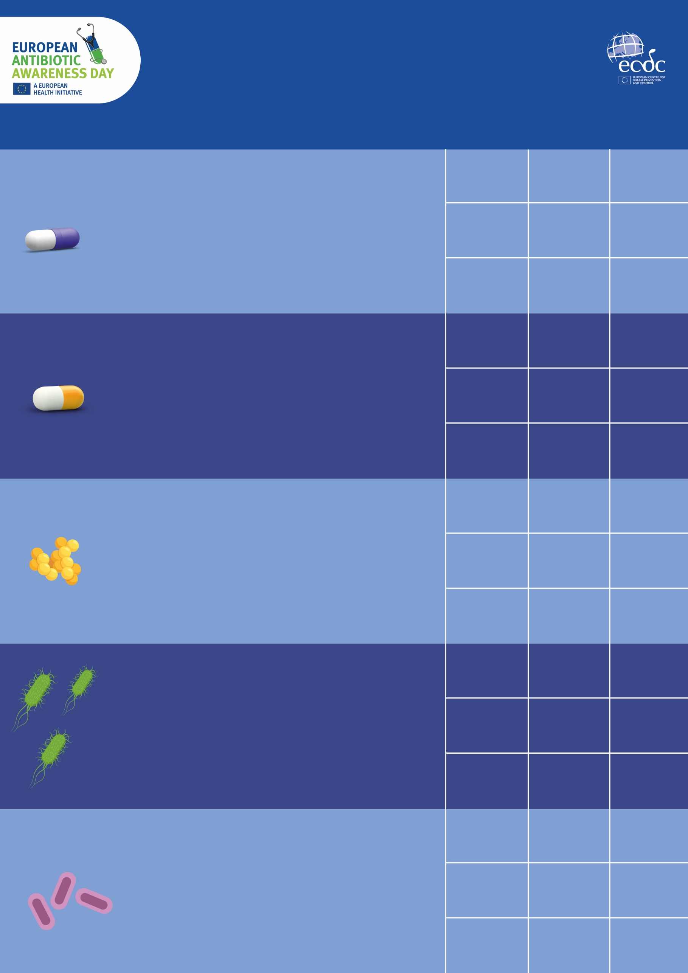
Antimicrobial resistance targets
How is the European Union doing?
*Population-weighted mean % consumption in ‘Access’ group.
As defined in the AWaRe classification of the WHO
At least 65% of the total consumption of antibiotics in humans belongs to the
‘Access’ group of antibiotics
**Percentage point difference from 2019.
-16.8%
59.8%
*
Number per 100 000 population
+49.7%
-12.2%
-2.5%
2030
TARGET
2.1
-5%
3.3
2022
2019
baseline
2.2
-
-10%
9.4
2030
TARGET
-
10.4
2019
baseline
2030
TARGET
4.8
-15%
2022
4.9
-
2019
baseline
5.6
-1.3%
**
2022
2019
baseline
61.1%
*
-
15.9
2030
TARGET
2022
-
19.9
2019
baseline
2022
8.7
-20%
+3.9%
**
65%
2030
TARGET
19.4
Reduce by 5% the total incidence of bloodstream infections with carbapenem-resistant
Klebsiella pneumoniae
Number per 100 000 population
Reduce by 10% the total incidence of bloodstream infections with third-generation cephalosporin-resistant Escherichia coli
Number per 100 000 population
Reduce by 15% the total incidence of bloodstream infections with meticillin-resistant Staphylococcus aureus (MRSA)
Defined daily doses (DDDs) per 1 000 inhabitants per day
Reduce by 20% the total consumption of antibiotics
in humans

